Course Code: CA LAB-XI (B) LAB on AI Practice using Python

**Ass 1. Installation of Python on Windows, Installing Packages, Loading data.**

## Download and Install Anaconda on Windows

### Step #1: Go To Anaconda.com

Go to [Anaconda.com](https://www.anaconda.com/distribution/#windows), and download the Anaconda version for Windows.

### Step #2: Download the Python 3 version for Windows.

Version 2 will not be updated past 2020, so do yourself a favor and start using V3.

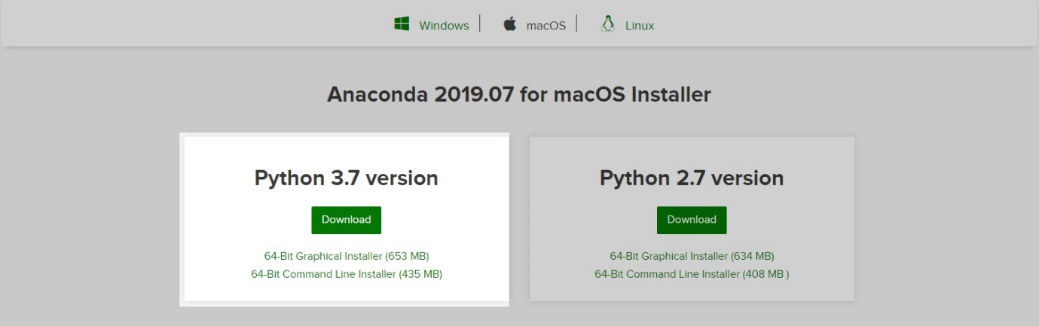

### Step #3: Double-click on the executable file.

To get the installation of Anaconda started on your operating system open the executable file in your Download folder.

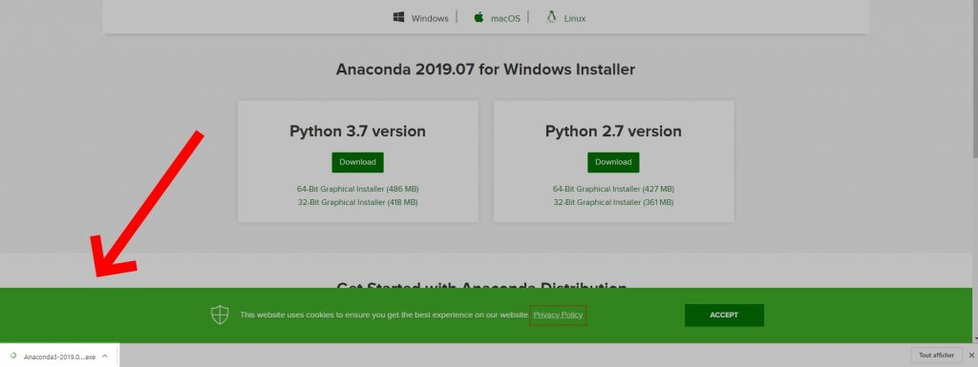

### Step #4: Click Next

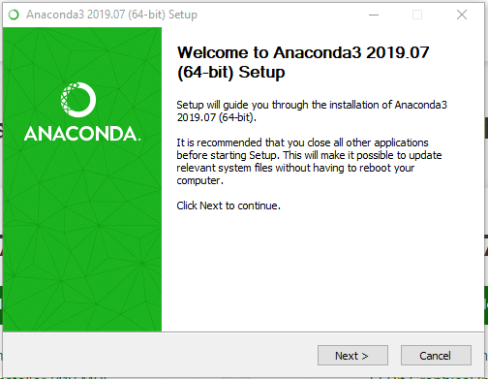

### Step #5: Click I agree to the terms and conditions

### Step #6: Select Who You Want To Give Anaconda To

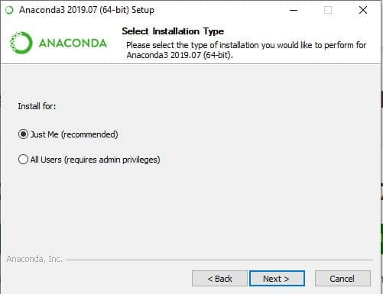

This step will ask you if you want to install Anaconda just for you or for all the users using this PC. Click “Just-Me”, or “All users”, depending on your preference. Both options will do but to select “all users” you will need admin privileges.

### Step #7: Select the installation location

If you have selected “All users”, by default, Anaconda will get installed in the C:\ProgramData\Anaconda3 folder. So make sure that you have at least the right amount of space available to install the subdirectory comparing it the the space required.

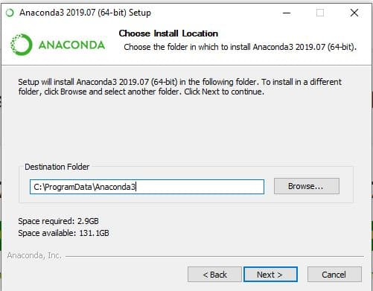

### Step #8: Select the environment variables

Depending on if you have any version of Python already installed on your operating system, or not, to do different set-up.

#### **If You Are Installing Python For The First Time**

Check the Add Anaconda to my PATH environment variable. This will let you use Anaconda in your command prompt.

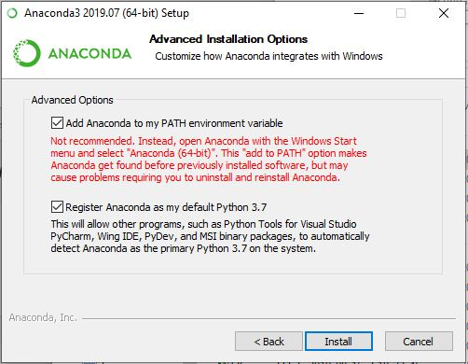

#### **If You Already Have Python Installed**

Leave Add Anaconda to my PATH environment variable unchecked.

Leaving it unchecked means that you will have to use Anaconda Command Prompt in order to use Anaconda.

So, unless you add the PATH later, you will not be able to use Python from your command prompt.

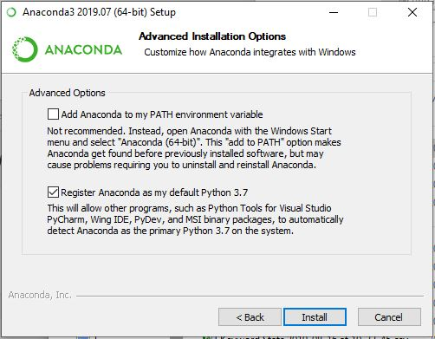

Python is not usually included by default on Windows, however we can check if any version exists on the system.

#### To know if you have Python Installed.

1. Go to Start Menu and type “Command Prompt” to open it.
2. Type the following command and hit the Enter key “python --version”
3. If nothing happens, you don’t have Python installed. Otherwise, you will get this result.

*$ python --version*

*Python 3.7.0*

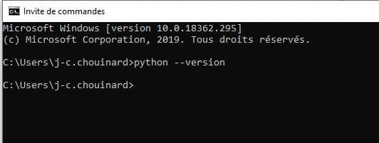

### Step #9: Click Next and then “Finish”.

### Step #10: See if Python Is Installed

If everything went right you can repeat the step 7 by opening your command prompt and enter “python --version”.

If everything is right, you’ll see this result.

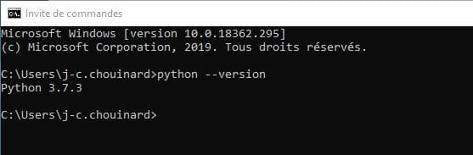

**Installing Packages:**

# Add packages to Anaconda environment in Python

Let’s see some methods that can be used to install packages to [Anaconda](https://www.geeksforgeeks.org/set-opencv-anaconda-environment/) environment.

There are many ways one can add pre-built packages to anaconda environment. So, let’s see how to direct the path in anaconda and install them.

**Using *pip* command :**

1. Open Anaconda Command prompt as administrator
2. Use **cd\** to come out of set directory or path.
3. Run **pip install** command.

E.g

pip install numpy

pip install scikit-learn

**Loading data.**

**pandas**is a powerful data analysis package. It makes data exploration and manipulation easy. It has several functions to read data from various sources.

*import pandas as pd  
mydata=pd.read_csv("C:\\Users\\Deepanshu\\Documents\\file1.csv")*